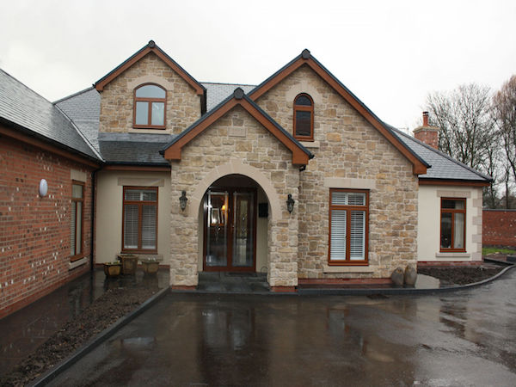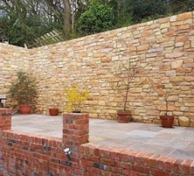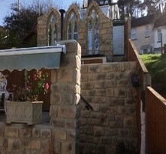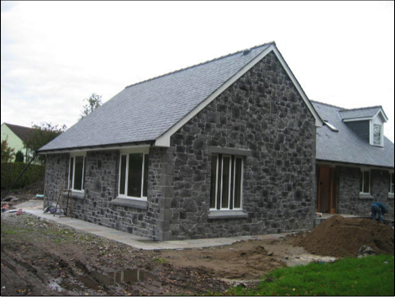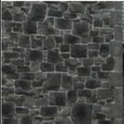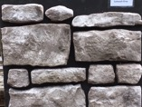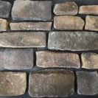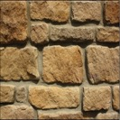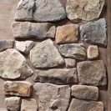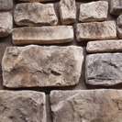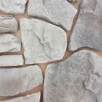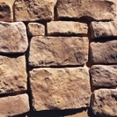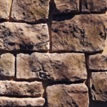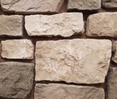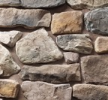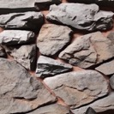

Stone Cladding Brochure

2022

* Arc Home Developments
* Units 2-4 , The Grove Industrial estate
* Consett , County Durham DH8 8BH

### As well as our range of stone cladding we can also produce a bespoke colour range for you

### Needs little or no maintenance as a great product cover walls internally and externally

### Due to having our own UK production site we can turn orders around Quickly

## **Stone Cladding**

## **Short lead times**

## **Bespoke service**

[www.thinbrick.co.uk](http://www.thinbrick.co.uk) Tel : 07828687899 email : sales@archomedevelopments.com

Our stone cladding is a light weight Eco friendly hand made stone Cladding veneer that is suitable for use both internally and externally. Used by builders, architects, developers and the general public . Arc Home Developments products are treated as if they were natural stone by capturing the nuances , colours , textures and shape that occur in nature.

* Allows for greater detail in design
* Large areas can be covered quickly
* Large range of styles and colours

Our stone cladding veneers can transorm a feature wall as a one off design in either a home or commercial development adding value as well as enhancing its appearance

# **Why use our Stone Cladding**

[www.eazyclad.com](http://www.eazyclad.com) Tel : 01432 839331 email : eazyclad@aol.com

This is a small sample of the stone cladding we produce

[www.thinbrick.co.uk](http://www.thinbrick.co.uk) Tel : 07828687899 email : sales@archomedevelopments.com

Blue Sandstone

Saltwash Grey

Golden Sandstone

Sandstone Mix

Hampshire Sandstone

Farmhouse

Hereford Sandstone

Higland weathered

Black Mountain

Castle Stone

Autumn Leaf

Debyshire Rough cut

Arc Home Development

Stone cladding

#### E

#### D

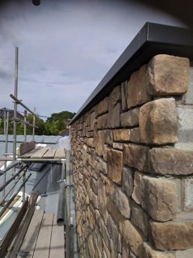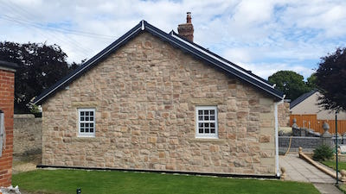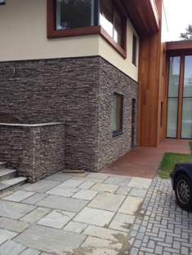

Our stone veneers can make all the diffence between a ordinary looking wall and a wall that will stand out from the crowd . We offer a bespoke matching stone service service and will try and produce to what ever colour range or shape you may require

We supply trade and private customers

Prices start from £35.00+vat a square metre

### **Arc Home Developments**

### **Stone cladding**

Tel 07828687899

Email: [sales@archomedevelopments.com](mailto:sales@archomedevelopments.com)

Web Site www.thinbrick.co.uk

Arc Home Developments

Units 2-4

Grove Industrial estate

Consett

County Durham

DH8 8BH

**Contact Details**